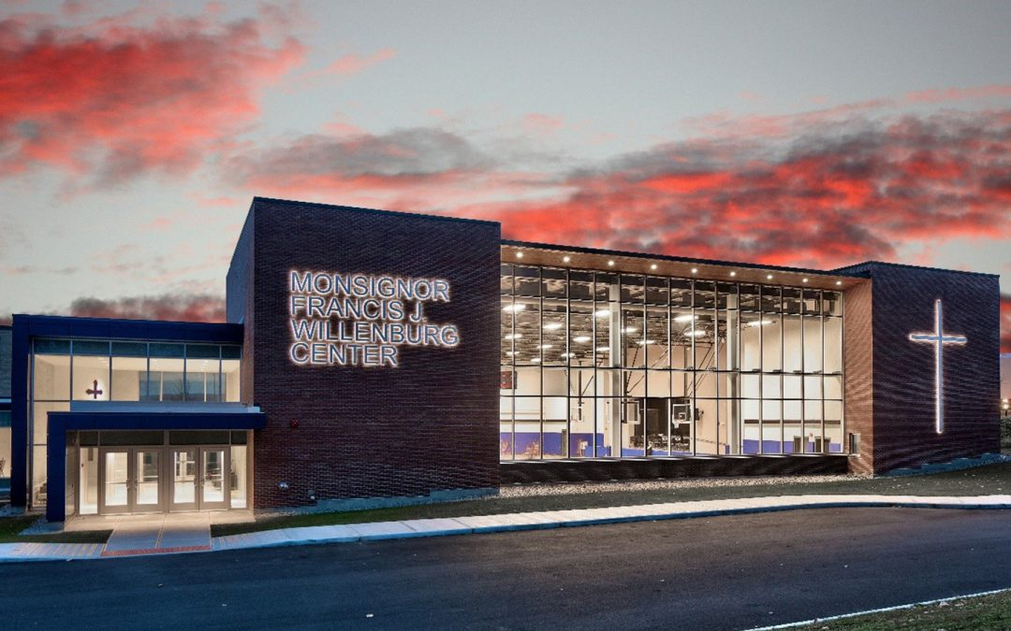

MINIMUM CAPACITY :-

The Minumum intake capacity

of students is between 300-620

children

LIBRARY :-

The Libarary is Available.

CANTEEN:-

The Canteen Facility is Available.

BOARDING :-

No availablility of boarding.

SPORTS :-

There are different categories

sports available.

Girls Volleyball

Boys Volleyball

Football

|  |  |  |
| --- | --- | --- |
| NOTRE DAME SCHOOLS  UTICA - SCHOOL |  |  |
|  |  |  |
| School Detail :- The liberal arts home for all Notre Dame students, with core curriculum courses and electives in everything from theology and philosophy to economics and creative writing. Arts and Letters is Notre Dame’s oldest and largest college or school. Arts and Letters is Notre Dame’s oldest and largest college or school. Arts and Letters is Notre Dame’s oldest and largest college or school. Arts and Letters is Notre Dame’s oldest and largest college or school. Arts and Letters is Notre Dame’s oldest and largest college or school. |  |